Name of Organization
DALIT JAN VIKAS SAMITI

Submitted in partially fulfilment of the requirements for the award of degree of
Bachelor of Technology
Computer Science and Engineering

Submitted to
LOVELY PROFESSIONAL UNIVERSITY
PHAGWARA , PUNJAB.



From 10/06/2023 to 17/07/2023

SUBMITTED BY :
NISHANT KUMAR
REGISTRATION NUMBER :
12203201

CONTEXT

- INTRODUCTION
- CERTIFICATE OF COMPLITION
- BENEFITES OF PLANTS
- Problem Identification
- PROBLEM FACED WITHOUT TREES
- PROBLEM FACED AFTER PLANTING TREES

- Objective to be achieved
- VARIOUS STEPS TO PROTECT OUR PLANT AND ALSO MOTIVATE PEOPLE TO ADOPT PLANTS

- Effectiveness of the Project

- PROOFS OF PROJECT
- CONCLUSION
- References/Bibliography/Citations

INTRODUCTION

What Is Community Development, Its Importance In present scenario? (Write briefly)

Community development projects are a means of strengthening a local region in one of many different ways. There are several types of community development projects, including those aimed at helping specific segments of the community, improving safety conditions, and enhancing social and cultural pursuits throughout the region.
Name and Details about the NGO you have chosen to work with

DALIT JAN VIKASH SAMITI
Motto: Be Good n Do Good!!! Nothing is Impossible!!!

Vision: Sustainable Rural Livelihoods (Rural development, Poverty Reduction and Environmental Management)

Goal/Mission: Empowering Rural Youth and Women towards a Sustainable Future by Creating Opportunities for Economic Empowerment and generating Employment by training and education with the help and application of modern technologies.

Core Values: Excellence, Integrity, Innovation, Collaboration, Inclusiveness and equal opportunities, sustainability, Respect, Accountability,

Guiding Principles: Sustainable Development Goals of United Nations (UN) in India

Our Focus Areas:
- Youth Development
- Women Empowerment
- Indigenous Sustainable Agriculture Practices

Name and brief of the NGO program you worked with.
YOUTH FOR CHANGE

youth for change program Is working for the well being of our planet and empowering today's youth .
In this program we are mentoring youth so that they can work efficiently for brighter future .

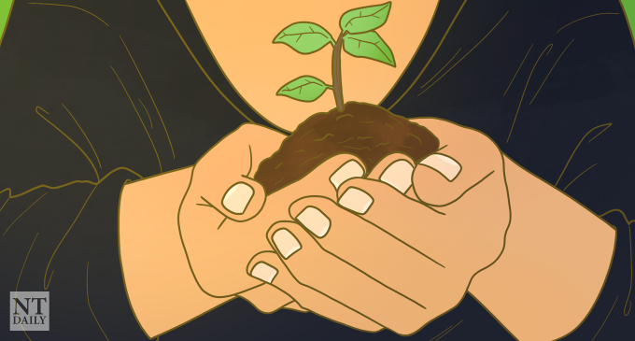
For decades we have understood that human activity is responsible for environmental changes. In general, these changes have been detrimental to the environment.
Scientists predict that within the next 50 to 100 years human activity would create regional combinations of environmental conditions that may be inhabitable by many of the terrestrial plants that evolved to survive in particular regions.
This will likely force a significant amount of plant species to extinction. Therefore, human activity threatens to significantly reduce plant biodiversity The human population continues to grow exponentially. This is causing us to need more land to live on, to build more houses, hospitals, schools, supermarkets and more. It also means more crops are required and more waste is produced. As a result, the land is often cleared to make space for this.
Habitats are built on or turned into farmland. The removal of these natural habitats directly reduces the number of plants and can lead to some species becoming endangered due to lack of appropriate habitat to support them.
Therefor, we need to plant more and more trees in our surroundings and with our initiative adopt a plant we suggest/convince people to plant tree on every special occasion and even on their religious festivals .

West Champaran(27.1547) is also known for its open border with NEPAL. There are many factories working in this district mainly the sugar factories in (Ramnagar , Narkatiaganj , Bagaha and Lauriya ) These factories are cutting land for there expansion and as plays lead role in increasing pollution .We also planted plants near the bank of rivers which enters INDIA from NEPAL because these rivers lead the way to heavy soil erosion and flood in northern BIHAR. so, we decided to work around these places and make our state clear and greener.

Polluted environment and air will be.
pure which would be helpful to reduce the number of deaths occurs from asthma; pneumonia and breath related other diseases. Plantation may not be a sole remedy to reduce global warming but yes, it can be a strongest strategy among all other options. Environment will be effectively pollution free at huge level. More greenery will be spread, and rain will be better

Plants and trees are our natural capital. They are fundamental to our life on earth offering food medicine and shelter. They also sequester carbon, fight pollution and bind the soil .

The solution to catastrophic events like wildfire, flood (highlight this , as this the major concern of Bihar and hence Gandak is called as Sorrow of Bihar .
During the monsoon period In 2021 ,the state experienced flood situation In four phases .About 79.31 lakh population was affected In 294 blocks of 34 district, a total of 88 flood relief camps were organised for the help of flood affected families .As per assessment ,about 6.64 lakh hectares of crop under various district has been damaged due to flood 902.08 crore was approved by the state government for payment of agriculture input grant to affected farmers .Along with this 28.40 lakh was paid to owners of 95 dead animals as Ex - Gratia grant .

Pandemic lies In restoring green cover and also In restoring natural balance. Planting and adopting plants can safeguard jobs , human health , and essential resources for millions of people .

CERIFICATE OF COMPLITION

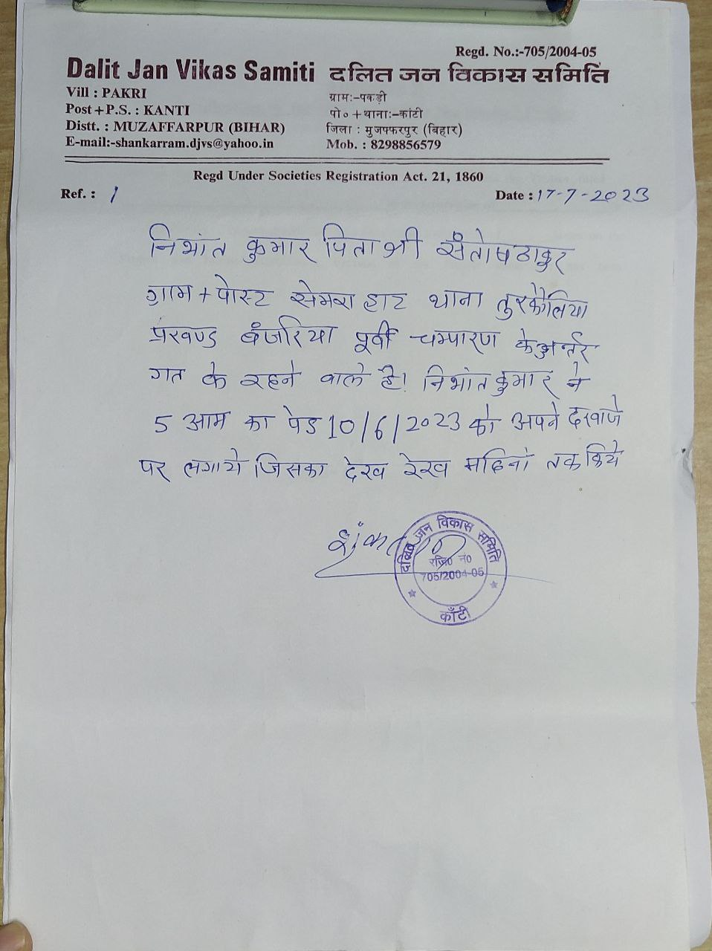

- BENEFITES OF PLANTATION
- Trees combat climate change :- Excess carbon dioxide (CO2) is building up in our atmosphere, contributing to climate change. Trees absorb CO2, removing and storing the carbon while releasing oxygen back into the air. In one year, an acre of mature trees absorbs the same amount of CO2 produced when you drive your car 26,000 miles.
- Trees clean the air :- Trees absorb odors and pollutant gases (nitrogen oxides, ammonia, sulfur dioxide and ozone) and filter particulates out of the air by trapping them on their leaves and bark.
- Trees provides oxygen:-In one year an acre of mature trees can provide enough oxygen for 18 people
- Trees conserve energy:- Three trees placed strategically around a single-family home can cut summer air conditioning needs by up to 50 percent. By reducing the energy demand for cooling our houses, we reduce carbon dioxide and other pollution emissions from power plants.
- Trees help prevent soil erosion:- On hillsides or stream slopes, trees slow runoff and hold soil in place.

PROBLEM IDENTIFICATION

- PROBLEMS FACED WITHOUT TREES
- CLIMATE CHANGE:-when there Is no plants then It will leads to unexpected climatic change Including extreme precipitation , wind disturbance , heat waves and drought .
- CONTAMINATION OF AIR / AIR POLLUTION:- Plants plays an Important part In balancing the gases present In our atmosphere as we know that natural air consists of 78% of nitrogen and 21% of oxygen and 0.04% carbon dioxide and some other gases and also the air we breath consists of 15%of o2 and 4% of co2 so If there Is no plants then there will be no proper Imbalancing of gases .
Img. showing rate of deforestation and afforestation
- SOIL EROSION:- Roots of trees binds up with soil and and prevent them from swapping with flow of water and heavy wind .Specially on hillsides and stream slopes , trees slows runoff and holds soil In place
- GLOBAL WARMING:- As we all knows that the only consumers of co2 on earths are of plants kingdom and according to research more than 25 percent of the warming was due to the impact of increased CO2 on vegetation. “There is no longer any doubt that carbon dioxide decreases evaporative cooling by plants and that this decreased cooling adds to global warming
- PROBLEM FACED AFTER PLANTING TREES
When you have planted multiple trees then you can except 80% success rate In the plantation .20% of trees may fail In long run even If the are planted
Despite adopting ample safe tree retention and protection strategies sometimes natural reason can cause the death of your tree sooner than expected life. Excessive rain, drought, storm etc. are some of the common natural circumstances when young tree losses Its life

Site Innovative and technical solution to the problem : Example GPS marking and Geo tagging and monitoring the plantation sites using an android application called MAPinr

OBJECTIVES TO BE ACHIVED
Our objective with this project Is not just to plant trees but also to strengthening the bond Involvement of Individual with nature but
Three objective should also be achived with this project
- Social :-
- Build community sprits and unity .
- Educate community about the benefits of trees and nature
2. Economical :-
To plant trees (and crops) for food security in order to provide food and nutrients for our people. The project will look at strategic approaches to promote agribusiness and agroforestry. It will be one of our objectives, to provide the public with access to information, about initiatives and incentives for agriculture, food production and food nutrition, on various scales; from the kitchen gardener to industrial farmer.

3. Environmental :-
We will plant trees to promote the conservation of our natural resources. Tree planting efforts will ensure our country conserves its biodiversity; and in conserving our biodiversity, we conserve our history; and our legacy.
- VARIOUS STEPS TO PROTECT OUR PLANT AND ALSO MOTIVATE PEOPLE TO ADOPT PLANTS
Government and other organisation are doing a great job of planting trees .People are being encouraged to plant trees In there surrounding through various campaigns run by government and also by non-profitable NGOs . But they do not have infrastructure to keep looking after them forever due to which trees may fail In long run so we must take some Initiatives to Adopt a plant and also to look after them after planting them.

- Planting commercial trees - We should make people understood that In today's world plants are highly In demand every field for furniture work paper work and a lot of other works .
- Planting medical plants :- There are a lot of plants In our surrounding which are used In making medicines
- Planting food and shelter providing plants
- One of our most unique Initiative taken by our foundation is to make people aware about the Importance of plant and promote people to plant trees with the Idea that was earlier used by our ancestors that we should plants trees on behalf of our children ( specially the girl child ) and also this Is In effect In a village near Bhagalpur named Dharhara this village Is more greener than other villages In Bihar .villagers of Dharhara celebrate the birth of girl child by planting saplings .This Idea Is also supported by Government of Bihar and Govt.of Bihar decided to launch a welfare scheme "PAHLI KILKARI YOJNA" . According to this practice a family plants a fruit bearing tree to celebrate the birth of girl child . The fruit provide financial insurance for the girl child as the family deposit the money by selling them in name of her .As the girl child gets younger the money which multiplies in course of time is spent on her education and on her marriage
- We are trying to make people understood what does adopting a plant means “ Adopting a plant means we are taking whole responsibilities of the plants from their birth till death “ with this we can ensure that the plants planted by them become their responsibility and also priority to look after them

- EFFECTIVENESS OF THE PROJECT
As this project Is long term project we can not make any conclusion In one day /month .so for keeping an eye over the effectiveness of this project we are using technology so that after being In the college campus or at any places we can make sure that our planted plants are growing well and making some difference In the environment

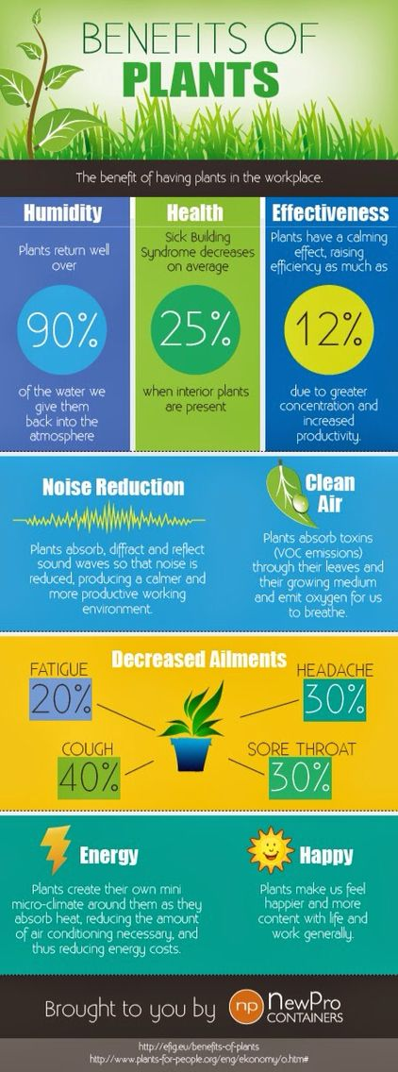
- PROOF OF PROJECT
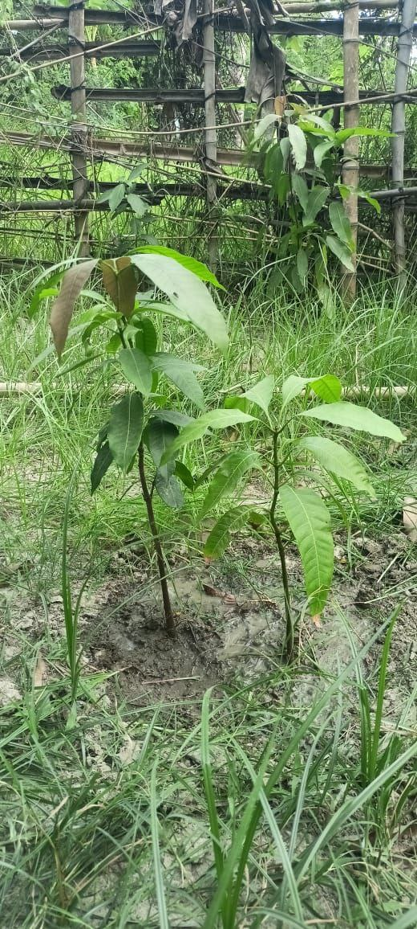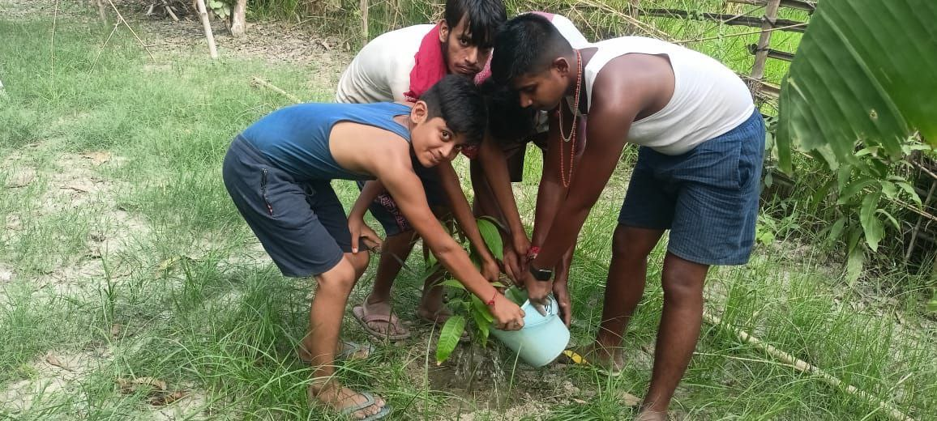

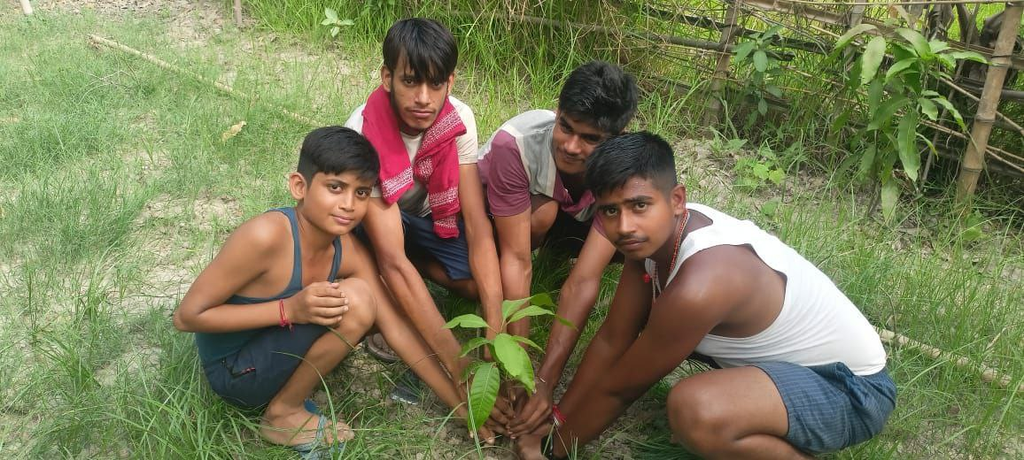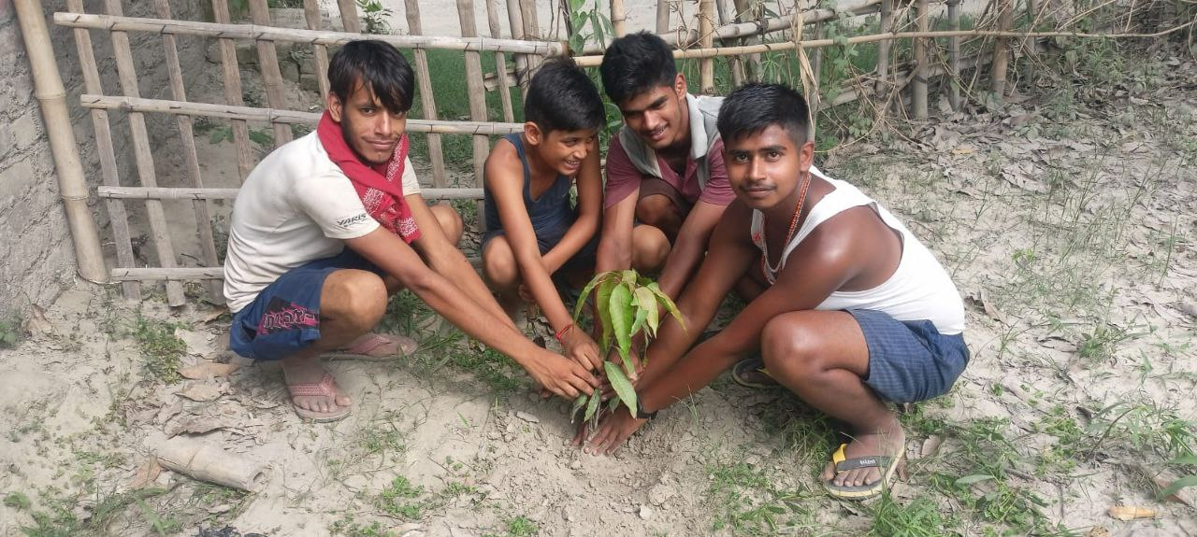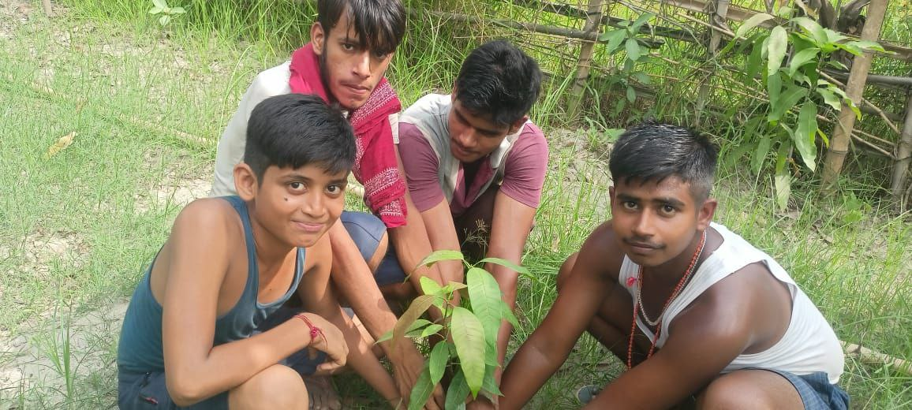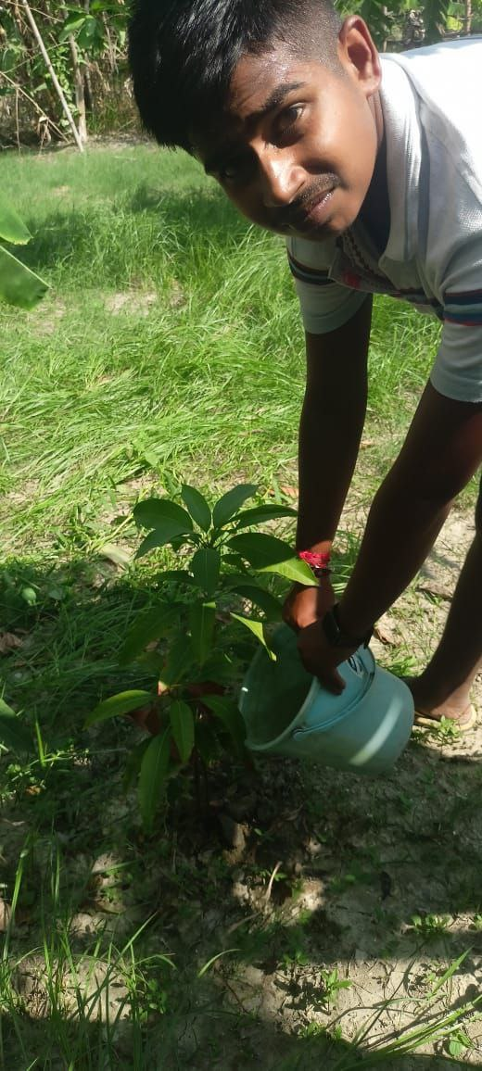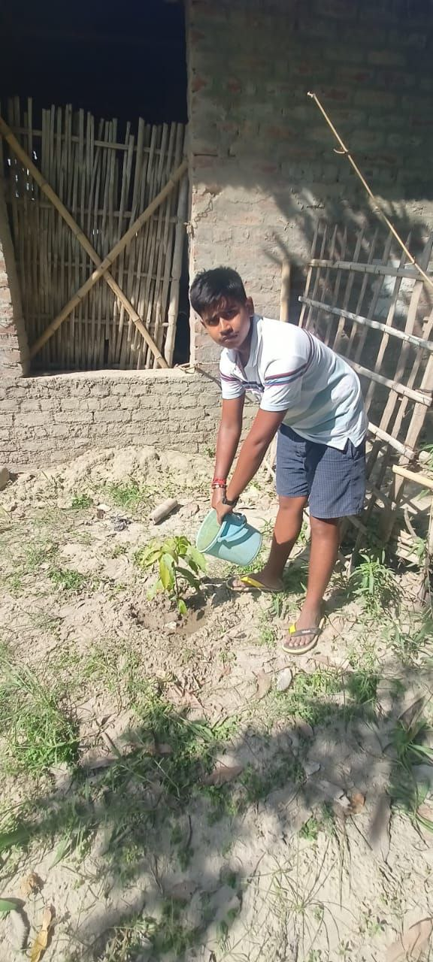

- Conclusion:-
It is time people must recognize the importance of tree plantation and contribute towards the same. The government must take this issue seriously and work towards involving more and more people to further the cause and even People must be sensitized about it so that they participate in large numbers. A big change in this direction is only possible if each one of us takes it as a responsibility to plant trees. Even if we do not have time to join an NGO and go with them on the drives regularly, we can make our contribution towards the cause by simply planting trees in our surrounding areas.
REFERENCES
Understanding Bihar Floods 2021 – Simplifying Official Information – Megh Pyne Abhiyan (wordpress.com)

BIHAR STATE DISASTER MANAGEMENT AUTHORITY (bsdma.org)

